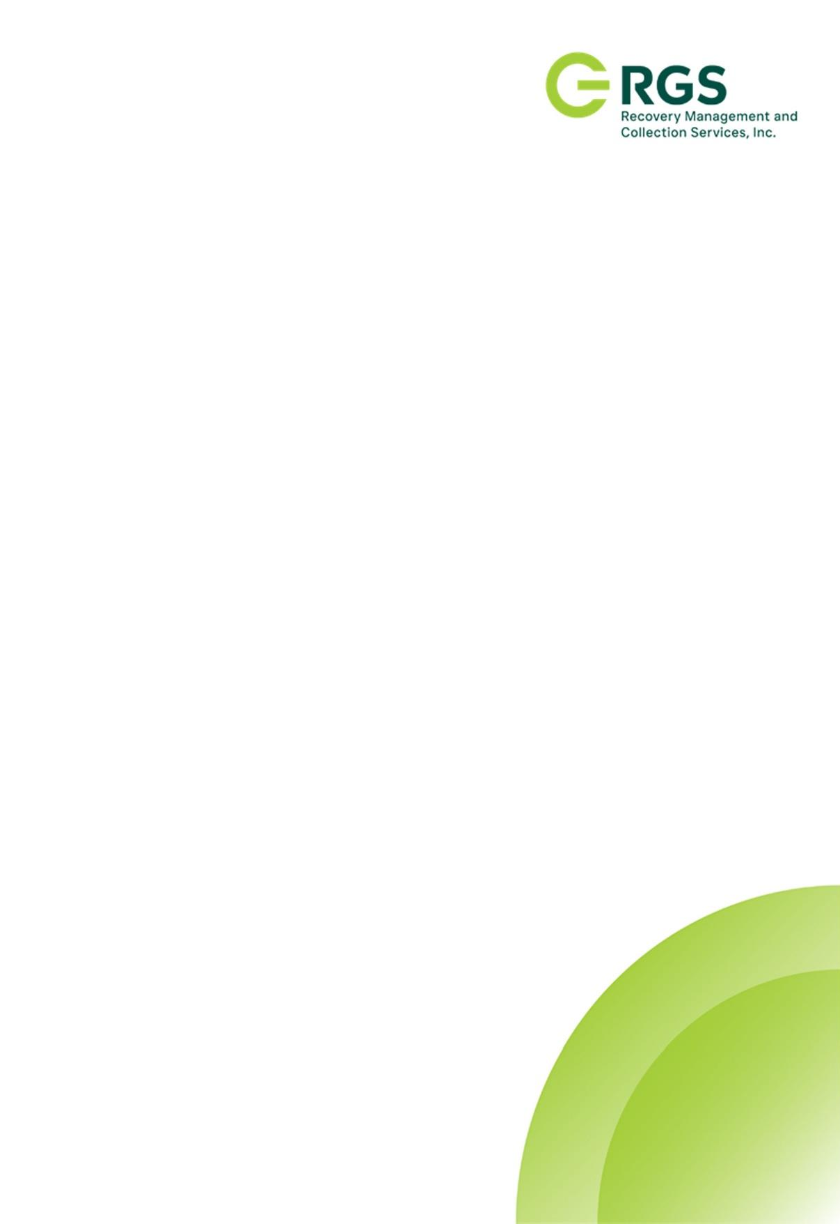

PRIVACY NOTICE

DATA PRIVACY COMMITMENT

RGS Recovery Management and Collection Services is committed to protecting personal data in compliance with the Data Privacy Act of 2012. We uphold the highest standards of confidentiality, integrity, and transparency by ensuring that data is processed lawfully, collected only for legitimate purposes, and secured against unauthorized access, loss, or misuse.

In compliance with the Data Privacy Act of 2012, we retain personal data only as long as necessary for its intended purpose or as required by law. Once the retention period ends, we securely delete or anonymize the data to prevent unauthorized access or misuse.

To strengthen data security, we implement encryption, multi-factor authentication, role-based access controls, regular audits, and real-time threat monitoring. Our security measures align with industry best practices and the Data Privacy Act of 2012, ensuring the protection of personal information under our care.

CONTACT US

For any concerns about how we handle your personal data you can go to Risk and Compliance Department or email it to us;
riskmanagement@rgsrecovery.com.ph / dataprotection@rgsrecovery.com.ph.

